**Errors GL Line Mapping of Mortgage Loan:**

1. **GL-52155-Arrangement Fee** wrong line to **GL-Catch All**

GL-52155-Arrangement Fee wrong line mapping to Catch All

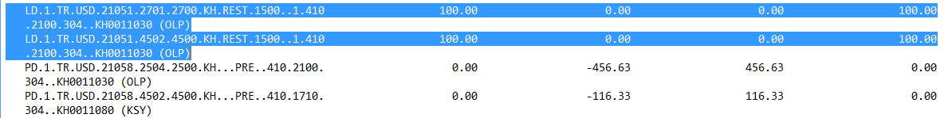

Should be remap to: 3723021-Unearn Inc.-Install LD Fee CL

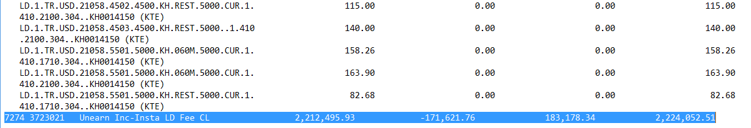

1. **Int. Inc. of Mortgage Loan** is wrong line mapping to **Int Inc–Std Dep–Sav Dep-Banks–Resident**

Wrong line mapping to: 512610-Interest Income–Standard Deposits–Saving Deposits with Banks–Resident

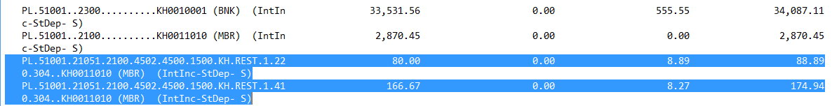

Should be remap to: 533110-Interest Income – Standard Loans – Real Estate Mortgage Loans – Individuals – Resident

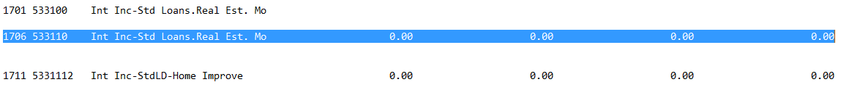

1. **PL-52250-Installment Loan Fees Earned of Mortgage Loan** is wrong line mapping to **Installment Loan Fees Earned**

PL-52250 is wrong line mapping to: 571140-Installment Loan Fees Earned



Should be remap to: 571130-Real Estate Mortgage Loan Fees Earned

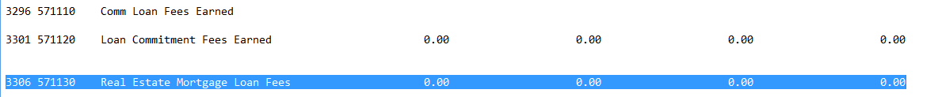

1. **PL-52155-Loan Arrangement Fee of Mortgage Loan** is wrong line mapping to **Miscellaneous Loan Fees and Service Charges**

PL-52155 is wrong line mapping to: 571160-Miscellaneous Loan Fees and Service Charges



Should be remap to: 571130-Real Estate Mortgage Loan Fees Earned



